Clemson Senior Design

LoRa Car Radio Bring-Up Procedure

Revision

Prepared By:

1775 West Hibiscus Blvd., Suite 200

Melbourne FL 32901

(321) 984-1671

Applicable Data Rights Statement:

AERONIX PROPRIETARY - COMPETITION SENSITIVE.

Documentation Authorization

|  |  |
| --- | --- |
| Review/Approval | Title Name |
| Originator: | D. Kaisner |
| **Approved By:**  Engineering | D. Kaisner |
| **Approved By:**  Quality Assurance | J. Finn |
| **Approved By:**  Configuration Management | D. Franks |
| **Approved By:**  Project Manager | T. Jandreau |

Document Revision History

|  |  |  |  |  |
| --- | --- | --- | --- | --- |
| **Rev** | **Description of Change** | **Changed By** | **Chg/Rel#** | **Date** |
| - | Initial Release | D. Kaisner | SP-XXXX | 8/26/25 |
|  |  |  |  |  |
|  |  |  |  |  |
|  |  |  |  |  |

Table of Contents

1. SCOPE 1

2. Referenced Documents 1

3. Test Execution and Recording 1

3.1. Datasheet Reporting 1

3.2. Test Equipment 1

4. Procedure 2

4.1. Visual Inspection 2

4.2. Voltage Rail Checks 3

4.3. Firmware Programming 5

4.4. Functional Test 5

Appendix A Test Datasheet A-1

Table of Tables

Table 2‑1 Reference Documents 1

Table 3‑1 Test Equipment Bill of Materials 2

Table 4‑1 Voltage Rails to Check 4

Table of Figures

Figure 4‑1 Test Configuration A 3

Figure 4‑2 Test Configuration B 5

# SCOPE

This documentation outlines the hardware specifications and priorities for the design work done by the Clemson Senior design team in creating the LoRa Base Station Evaluation Board and the LoRa Car Radio Evaluation Board.

The purpose of these designs is to facilitate research into how LoRa radios can be used to create mesh networks for utilization on trains for various signaling and data monitoring applications.

# Referenced Documents

|  |  |
| --- | --- |
| Table ‑ Reference Documents | |
| **Document Number** | **Reference** |
| AE304193-001 | LoRa Radio Evaluation Design Hardware Requirements |
| AE304194-001 | LoRa Radio Evaluation Design Software Requirements |
| AE304195-001 | LoRa Car Radio Programming Procedure |
| AE104079-001 | Car Radio Schematic |
| AE104077-001 | Car Radio PCB |

# Test Execution and Recording

The procedure is to be run in the document order. If any failure is observed, the test is to be halted, marked as a failure, and the issue remedied before restarting the test from the beginning.

## Datasheet Reporting

The data sheets are indexed to the corresponding test procedure paragraphs. Record actual test data on the applicable entry line on the test datasheet. Where directed, verify a satisfactory completion of an action or satisfactory observation by marking a “P” (for pass) on the applicable data sheet. If completion of an action or an observation is unsatisfactory, mark an "F" (for fail) on the applicable data sheet. No entry line should beleft blank. If the specific test does not apply, write "N/A" for the entry.

## Test Equipment

The following test equipment is required to complete the testing herein. Equivalent equipment is acceptable.

Table ‑ Test Equipment Bill of Materials

|  |  |  |  |
| --- | --- | --- | --- |
| **Item** | **Manufacturer** | **Part Number** | **Description** |
| 1 | BK Precision | 9202 | Benchtop Power Supply |
| 2 | BK Precision | 2860A | Multimeter |
| 3 | Aeronix | AE10XXXX-001 | Power Cable |
| 4 | Segger | J-Link | JTAG Programmer |
| 5 | Any | Windows | Test PC with programming software and firmware |
| 6 | Adafruit | 954 | USB to TTL Serial Cable |
| 7 | Keysight | DSO2024A | Oscilloscope |

# Procedure

## Visual Inspection

1. Visually inspect the PCBA to the IPC-610 standard and class specified in the drawing (AE104077-001).

## Voltage Rail Checks



Figure ‑ Test Configuration A

1. Set the multimeter (Item 2) in diode check (beep) mode.
2. Using the multimeter, probe the ground pad (pin 2) of the input barrel jack (J3) (GND) with the black multimeter probe, and with the red probe verify the following locations are connected to ground:
   1. P2 pin 1 (GPIO Header)
3. With the black multimeter probe still on the ground pad (pin 2) of the input barrel jack (J3) (GND) and using the red probe, verify that the following nets are **NOT** connected to ground:
   1. J3 pin 1 (PWR_JACK)
   2. U6 pins 14-16 (+5V)
   3. P2 pin 2 (+3V3)
   4. U12 pin 1 (+3V3_RF)
4. Place black multimeter probe on U6 pins 14-16 (+5V) and using the red probe, verify that the following nets are **NOT** connected:
   1. P2 pin 2 (+3V3)
   2. U12 pin 1 (+3V3_RF)
5. Place black multimeter probe on P2 pin 2 (+3V3) and using the red probe, verify that the following nets are **NOT** connected:
   1. U12 pin 1 (+3V3_RF)
6. Disconnect any connected output power cables from the DC power supply (Item 1). Power on the supply without enabling the output.
7. Set the DC power supply to output 5V and set the current limit to 200mA.
8. Connect the input power cable (Item 3) banana jacks to the output jacks of the DC power supply, and the barrel connector to the UUT’s barrel jack, as shown in Figure 4‑1.
9. **(WARNING: If the UUT draws too much current, be prepared to turn off power supply quickly to reduce damage to the UUT)** Enable the power supply.
10. **(WARNING)** Verify that the UUT does not draw more than the current limit, entering the power supply into constant current mode. **If the board is drawing more than 200mA, disable the power supply**, end this procedure, and diagnose the issue.
11. Place the black multimeter probe on the ground pad (pin 2) of the input barrel jack (J3) (GND) and using the red probe, verify the following nets voltages:

Table ‑ Voltage Rails to Check

|  |  |  |  |
| --- | --- | --- | --- |
| **Item** | **Pin** | **Net** | **Value** |
| a | J3 pin 1 | PWR_JACK | 5V ±100mV |
| b | U6 pins 14-16 | +5V | 5V ±100mV |
| c | P2 pin 2 | +3V3 | 3.3V ±100mV |
| d | U12 pin 1 | +3V3_RF | 3.3V ±100mV |

1. Power on and set up the Oscilloscope (Item 7) with the following settings on channel 1: 1V/div, 5us/div, measurement frequency channel 1.
2. Probe Y1 pin 1 with the channel 1 probe. Verify that the clock signal is 16MHz.
3. Probe Y2 pin 1 with the channel 1 probe. Verify that the clock signal is 32MHz.
4. Power off the UUT.

## Firmware Programming

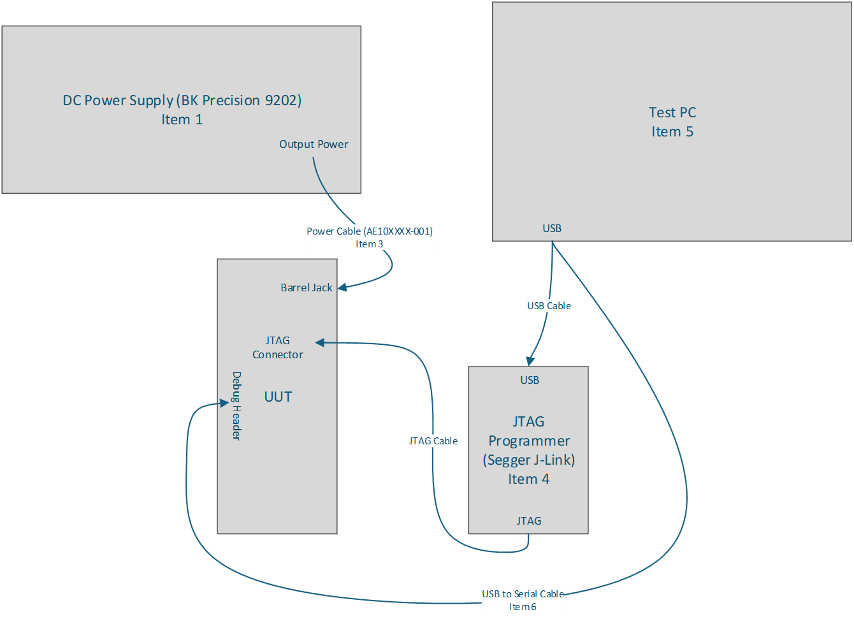

Figure ‑ Test Configuration B

1. Connect the JTAG Programmer (Item 4) to the test PC (Item 5) with the included USB cable. Connect the JTAG Programmer to the UUT with the included JTAG cable, as shown in Figure 4‑2.
2. Connect the USB to TTL Serial Cable (Item 6) to the test PC (Item 5) and to the UUT debug header (P2) with the following pinout:

|  |  |
| --- | --- |
| **P2 Pin** | **USB to TTL** |
| 1 | GND (black) |
| 8 | Rx (white) |
| 10 | Tx (green) |

1. Program the UUT according to AE304195-001 LoRa Car Radio Programming Procedure. Verify programming is successful.

## Functional Test

1. Open a serial terminal to the UUT on the test PC using the following parameters:
   1. Baud Rate: 115200
   2. Parity: None
   3. Stop Bits: 1
2. Reset the UUT by pressing SW1.
3. Verify the welcome screen prints to the console.
4. Enter command “bit.lora” into the console. Verify built-in test shows as Pass.
5. Enter command “bit.gps” into the console. Verify built-in test shows as Pass.
6. Enter command “bit.imu” into the console. Verify built-in test shows as Pass.
7. Enter command “bit.i2c” into the console. Verify built-in test shows as Pass.
8. Test Datasheet

Record the results of each test in the datasheet below.

|  |  |
| --- | --- |
| **Date** |  |
| **Tester** |  |
| **Unit Part Number** |  |
| **Unit Serial Number** |  |

|  |  |  |  |  |
| --- | --- | --- | --- | --- |
| **Section** | **Description** | **Expected** | **Observation** | **Pass/Fail** |
| 4.1.1 | Visual Inspection | Pass |  |  |
| 4.2.2.a | Ground Net Check | Connected |  |  |
| 4.2.3.a | PWR_JACK not shorted | Open |  |  |
| 4.2.3.b | +5V not shorted | Open |  |  |
| 4.2.3.c | +3V3 not shorted | Open |  |  |
| 4.2.3.d | +3V3_RF not shorted | Open |  |  |
| 4.2.4.a | +3V3 not shorted | Open |  |  |
| 4.2.4.b | +3V3_RF not shorted | Open |  |  |
| 4.2.5.a | +3V3_RF not shorted | Open |  |  |
| 4.2.10 | UUT current draw | <100mA |  |  |
| 4.2.11.a | PWR_JACK voltage | 5V ±100mV |  |  |
| 4.2.11.b | +5V Voltage | 5V ±100mV |  |  |
| 4.2.11.c | +3V3 Voltage | 3.3V ±100mV |  |  |
| 4.2.11.d | +3V3_RF Voltage | 3.3V ±100mV |  |  |
| 4.2.13 | Y1 Oscillator Frequency | 16MHz ±100kHz |  |  |
| 4.2.14 | Y2 Oscillator Frequency | 32MHz ±100kHz |  |  |
| 4.3.2 | Programming successful | Pass |  |  |
| 4.4.3 | Welcome screen on reset | Present |  |  |
| 4.4.4 | “bit.lora” test pass | Pass |  |  |
| 4.4.5 | “bit.gps” test pass | Pass |  |  |
| 4.4.6 | “bit.imu” test pass | Pass |  |  |
| 4.4.7 | “bit.i2c” test pass | Pass |  |  |
| **OVERALL** | | | |  |